# **System Functionalities and Flows**

### **New Flows**

1. **Open Door Warning:** System now provides a warning to the user when the door was opened during cooking. This flow is based on information received from oven states.
2. **Current Oven Temperature:** Users can inquire about the current oven temperature. The oven response reflects on whether there is an active pre-heating process in the oven or whether the oven has reached the designated temperature.
3. **Oven Speech Rate (speed):** Users can now control the oven’s speech/output audio speech rate. The oven offers 3 different speeds: Slow, Normal, and Fast.
4. **Oven Speech Volume (loudness):** Users can now control the oven’s speech/output audio volume level. The oven offers 3 different volume levels: Low, Medium, and High.
5. **Oven Speech Control:** Users can now control the status of oven’s speech. Users can turn off/ turn on system’s speech.

**Below is a couple of screenshots related to the mentioned flows above:**

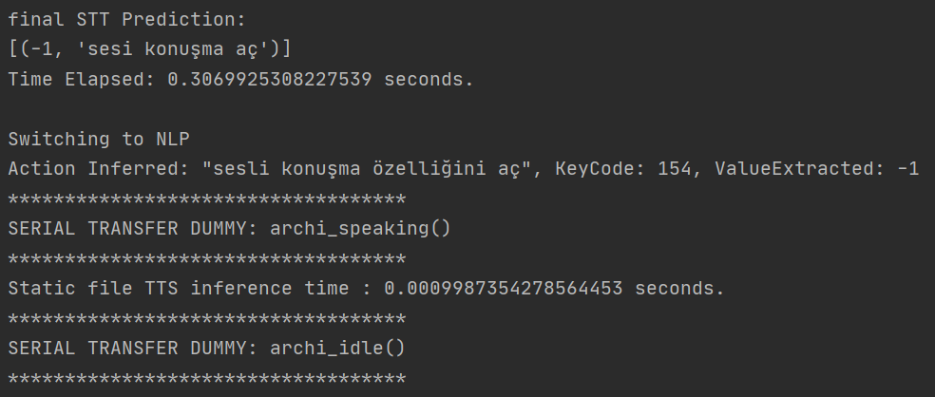

**Oven Speech Control** 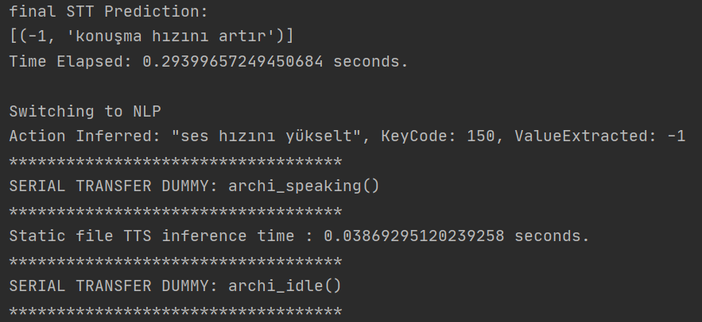

**Oven Speech Rate (speed)**

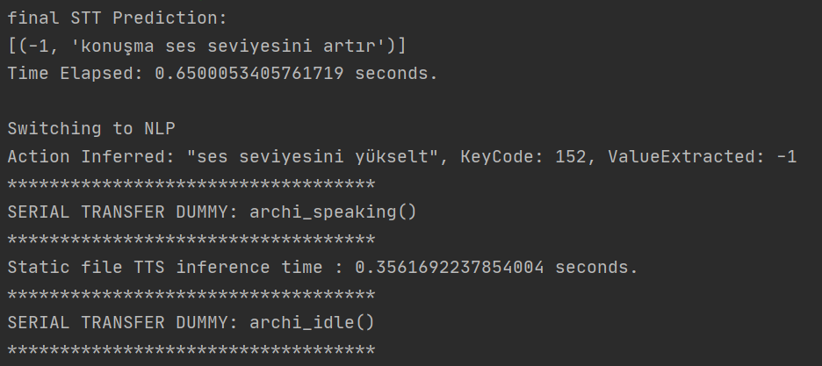

**Oven Speech Volume (loudness)**

# **System Features**

### **Speaker Verification**

We conduct research and literature scan on the state-of-the-art methods for performing speaker identification and verification in low-resource setting. For the purpose of this project, speaker verification must be done online without training. Hence, we will utilize speaker embeddings and proximity measure to identify different speakers based on their given test recordings. We utilized Nvidia NEMO’s implementation for SpeakerNet to create speaker vectors. To compare speaker vectors we use Cosine Similarity. We conduct further experiment to define a threshold value for Cosine Similarity as this value determines whether a user was already identified by the system or not.

### **Bugs Fixing**

##### Spelling correction Related Bugs

A list words that were wrongly corrected to other words were added to spelling correction model vocabulary.

##### Missing system features bugs

Update system behavior for certain edge cases according to newly implemented flows.